MODULE SIZE.

PLANNING FOR ACTION TO BUILD ALLIANCES FOR ALTERNATIVE ECONOMIC MODELS

Aim of exercise
To identify the organisations and people with whom you need to engage in order to build a wide alliance for bringing about large scale system change. This planning for action exercise aims to begin to support education activists to start to think about how to build alliances for “system change” (see box below)
Activity

ActionAid, EI and GCE believe we need to work together to change the terms of the debate around austerity, debt tax etc – all the issues outlined in this module - it will require moving beyond normal constituencies, and reaching out to a wider range of other Trade Unions, CSOs, academics etc (i.e. to debt justice, tax justice movements) to build wide constituencies for change/campaigning.

It is vital for education activists to build voice and understanding within their own organisations, as well as linking with others that hold specific knowledge and expertise. Below we have listed some obvious allies to reach out to – and then follows a simple power mapping activity.

In order to reach out to allies and targets education activists can:
- Contact national or regional Global Tax Justice Networks (see http://www.globaltaxjustice.org) and debt justice coalitions (https://debtjustice.org.uk/ )
- Reach out to other sector networks, such as health networks or social protection networks – working together to be stronger in advocating for more social spending together.
- Work across governments and sectors It is also necessary for education movements to reach beyond their normal sector discussions, and engage in more strategic processes of change, connecting with Ministries of Finance and Heads of State with new alliances for tax and fiscal justice. It will also require creating new norms and formulas to help Ministries of Finance and Governments to factor in the long-term returns to investment in education so that education spending is not seen as a consumption expenditure in medium term expenditure frameworks and other planning / budget documents but as an investment in the future
- Reach out to Trade Unions who are also working against austerity to joining together to resits cuts
- Reach out to small and medium-sized enterprises (SMEs), as demonstrating support from business can strengthen campaigns. For instance, SMEs don’t have the same capacity to dodge taxes and don’t benefit from the generous tax incentives received by multinational companies, they may also support calls to see building a well-trained/education workforce as a core “infrastructure” cost or believe that foreign debts are strangling efforts to invest in the countries needs.
- Collaborate with the media to expose both the scale and specific examples of tax injustice; the role of the IMF in giving advice, or the levels of debt servicing and what it is doing to erode public service spending
- Progressive academics and research institutes may also be useful allies to research alternatives.
- Join with feminist organisations who campaign for alternative models of economics
- Joining with climate justice movements who are calling for a different way to do economic planning to account for a just transition
- Establish connections with tax administrations. In most countries, tax administrators are sympathetic, recognising the need to improve systems and increase capacity. As a government department they are unlikely to be able to provide support publicly but may be able to share information from behind the scenes.

The level of influence and attitudes of each of the key actors can be analysed using a power map. This is a simple matrix with a horizontal and vertical axis (see below). The vertical axis indicates the level of influence or power each person/ organisation has to help you achieve your goal. Those with the most power or influence are placed at the top of this axis. The horizontal axis indicates whether people/groups support or oppose your specific objectives.

Those most opposed to your desired changes are placed to the left, and those in support of your objectives are at the right.
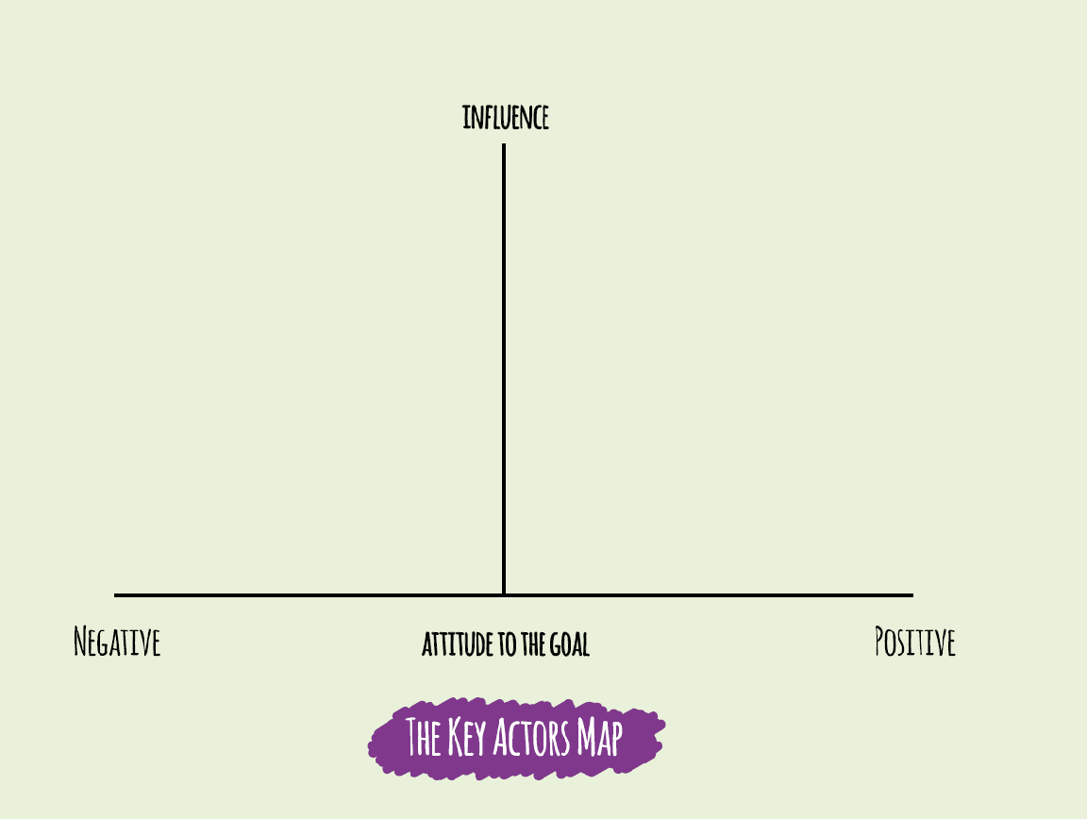
Step 1: Identify the individual/organisation holding the most influence in terms of delivering your desired outcome (your goal). Place them on the power map, according to how much influence and how supportive of your advocacy goals they are.

Step 2: Place other individuals/ organisations in turn on the power map. Consider the relative power of the stakeholders in your advocacy. Who is closest to the key decision makers? Move them around if needed.

Step 3: When your map is complete, identify the two or three locations within the map where you feel your advocacy might affect the greatest influence. Are there people or organisations who hold power and who you might successfully influence or build strategic relationships with?

Step 4: Who are the strategic allies (with whom you share common values and a long-term basis for united work), or tactical allies (who may only be reliable allies for the duration of the campaign or a particular aspect of the issue)? What can they offer to the work? What is their expertise or strength (e.g. mobilisation, national coverage, data collection, knowledge of issues)?

